EXERCISE 3.3

**NCERT Solutions for Class 10 Chapter 3-**

**Pair of Linear Equations in Two Variables**

EXAMBUDDY

Question 1:

Solve the following pairs of linear equations by the elimination method:

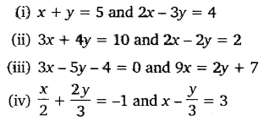

**Solution:**

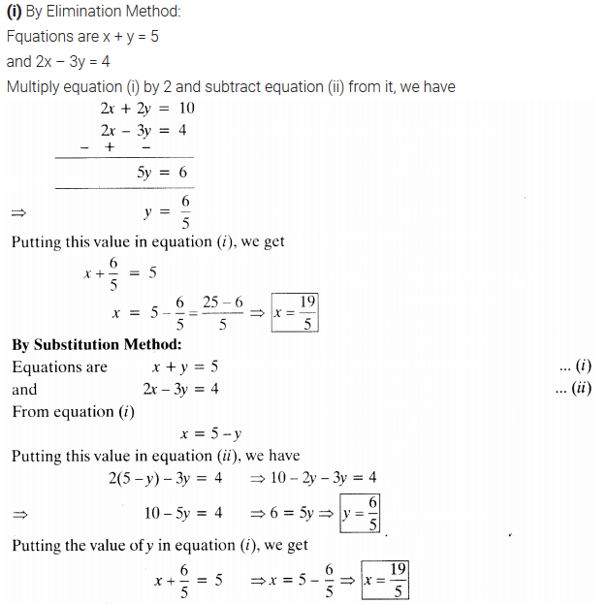

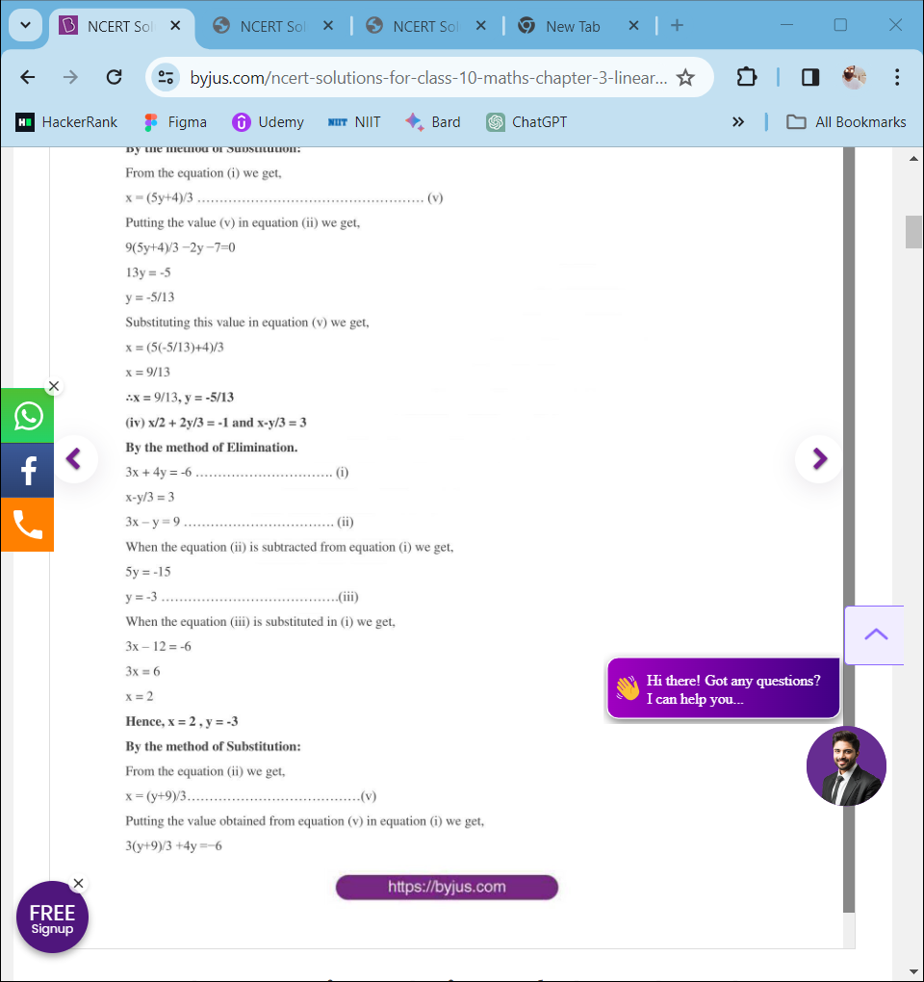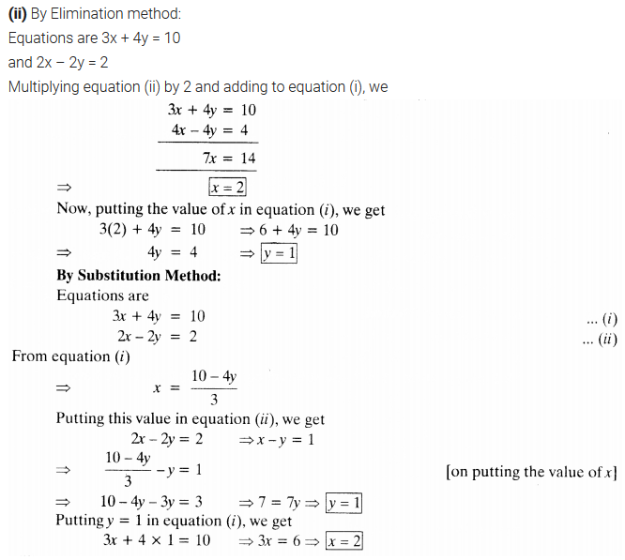

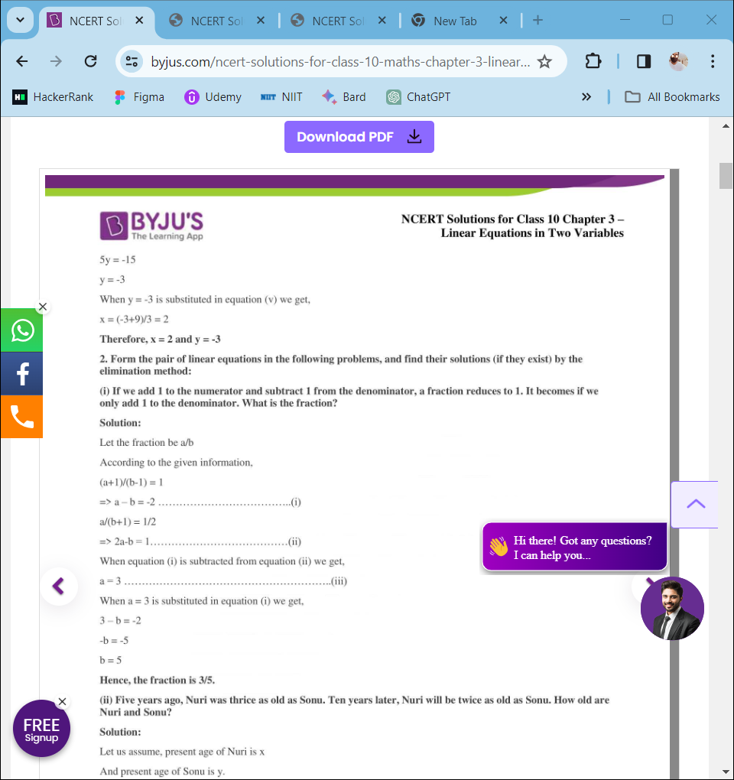

Question 3:

Form the pair of linear equations for the following problems and find their solution by substitution method:

1. If we add 1 to the numerator and subtract 1 from the denominator, a fraction reduces to 1. It becomes 1/2, if we only add 1 to the denominator. What is the fraction?.
2. Five years ago, Nuri was thrice as old as Sonu. Ten years later, Nuri will be twice as old as Sonu. How old are Nuri and Sonu?
3. The sum of the digits of a two-digit number is 9. Also, nine times this number is twice the number obtained by reversing the order of the digits. Find the number.
4. Meena went to a bank to withdraw ₹2000. She asked the cashier to give her ₹50 and ₹100 notes only. Meena got 25 notes in all. Find how many notes of ₹50 and ₹100 she received.
5. A lending library has a fixed charge for the first three days and an additional charge for each day thereafter. Saritha paid ₹ 27 for a book kept for seven days, while Susy paid ₹21 for the book she kept for five days. Find the fixed charge and the charge for each extra day.

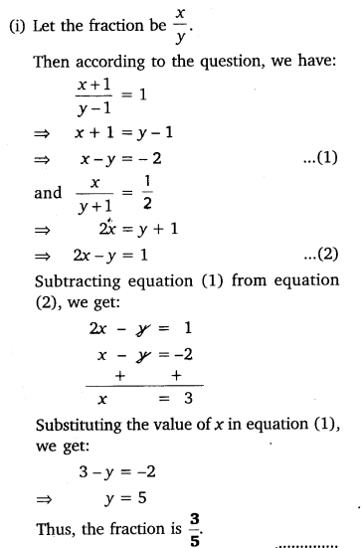Solutions:

